**Module 3: Docker Part 1**

**Assignment – 5**

1. Create a sample HTML file



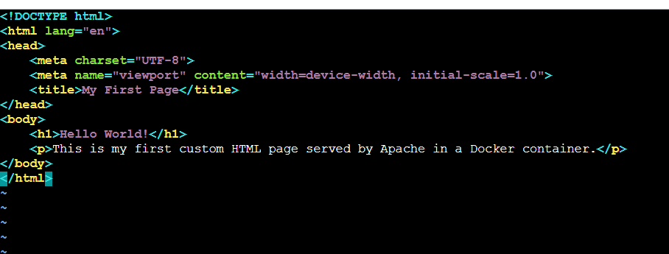

1. Use the Dockerfile from the previous task

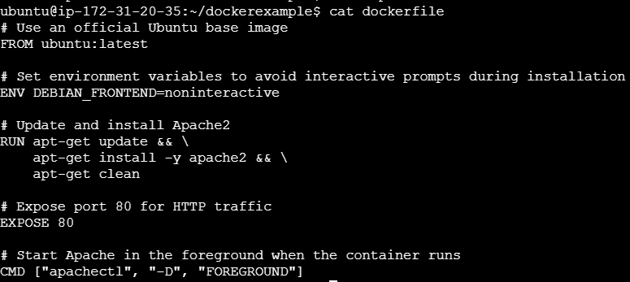

3. Replace this sample HTML file inside the Docker container with the default

Page

First build the image

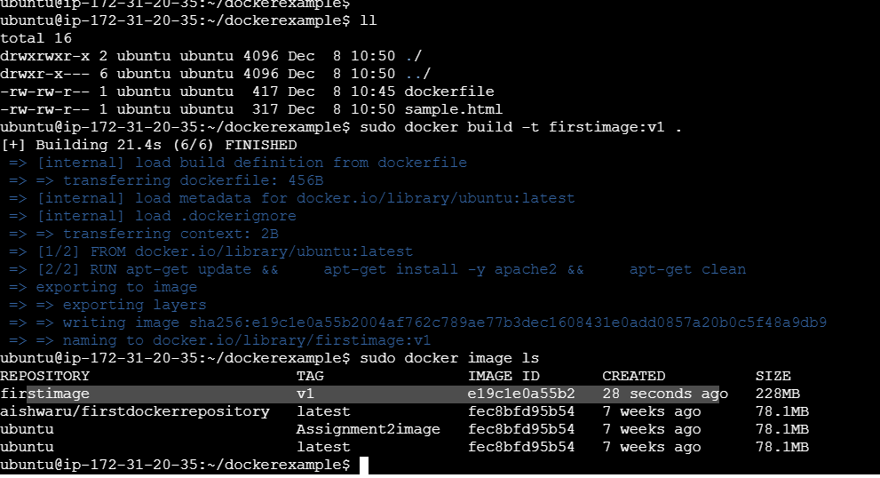

Here replacing the sample.html by using volume





Able to access sample.html

